**Practical 7**

**Exercise:-** Create an application using Filters (uppercase,lowercase,filter filter,

orderby)

**Program:- uppercase , lowercase filter**

<!DOCTYPE html>

<html lang="en">

<head>

<meta charset="UTF-8">

<meta name="viewport" content="width=device-width, initial-scale=1.0">

<!-- <script src="https://ajax.googleapis.com/ajax/libs/d3js/7.8.5/d3.min.js"></script> -->

<script src="https://cdnjs.cloudflare.com/ajax/libs/angular.js/1.8.3/angular.min.js"></script>

<title>Document</title>

</head>

<body>

<div ng-app="" >

<h1>Name: <input type="text" ng-model="name"></h1>

<H1>Output : {{ name | uppercase }}</H1>

<h1>Output : {{ name | lowercase }}</h1>

<h1>Currency: <input type="text" ng-model="cur"></h1>

<h1>In Dolar : {{ cur | currency }}</h1>

</body>

</html>

**Output:-**

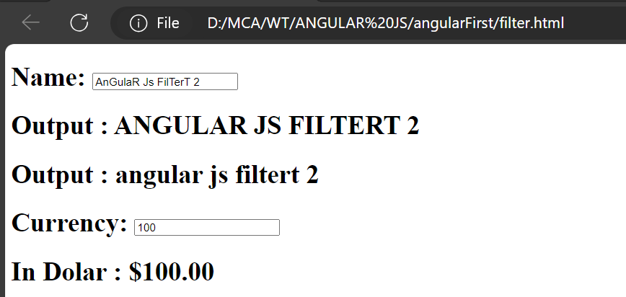

**Program:- filter filter**

**filter.html**

<!DOCTYPE html>

<html lang="en">

<head>

<meta charset="UTF-8">

<meta name="viewport" content="width=device-width, initial-scale=1.0">

<!-- <script src="https://ajax.googleapis.com/ajax/libs/d3js/7.8.5/d3.min.js"></script> -->

<script src="https://cdnjs.cloudflare.com/ajax/libs/angular.js/1.8.3/angular.min.js"></script>

<!-- <script src="./angular.min.js"></script> -->

<script src="./filterJS.js"></script>

<title>Document</title>

</head>

<body>

<div ng-app="firstapp" ng-controller="firstCTR">

<h1>Apply Filter: <input type="text" ng-model="test"></h1>

<li ng-repeat="x in colors | filter:test">

{{x}}

</li>

</div>

</body>

</html>

**filter.js**

var app=angular.module('firstapp',[]).controller('firstCTR',function($scope){

$scope.colors=[

'red',

'blue',

'green',

'yellow',

'pink',

'orange',

'purple'

];

})

**Output:-**

**Before Any Filter**

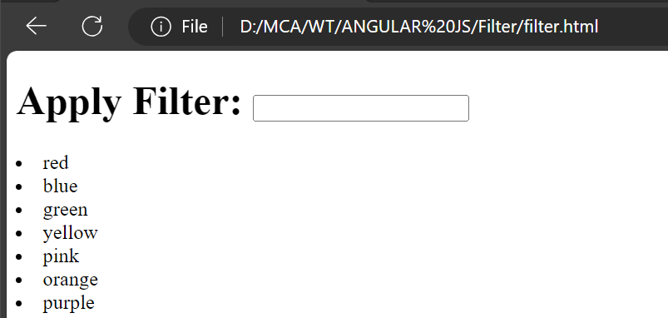

**After Applying Filter (‘l’)**

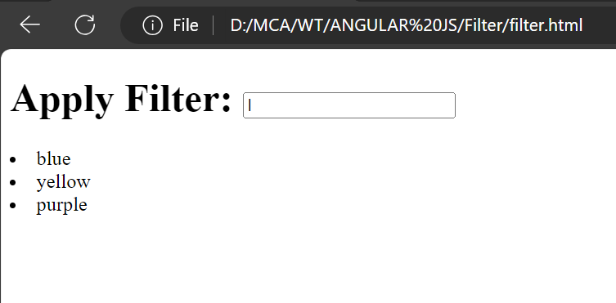

**After Applying Filter (‘e’)**

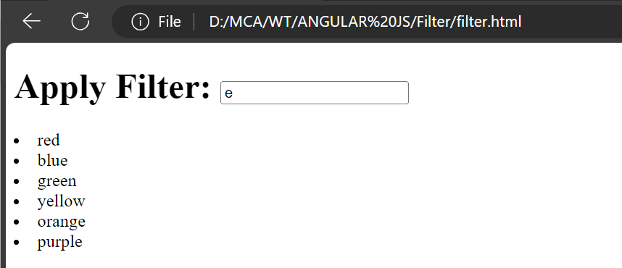

**Program:- orderBy filter**

<!DOCTYPE html>

<html lang="en">

<head>

<meta charset="UTF-8">

<meta name="viewport" content="width=device-width, initial-scale=1.0">

<!-- <script src="https://ajax.googleapis.com/ajax/libs/d3js/7.8.5/d3.min.js"></script> -->

<script src="https://cdnjs.cloudflare.com/ajax/libs/angular.js/1.8.3/angular.min.js"></script>

<!-- <script src="./angular.min.js"></script> -->

<title>Document</title>

</head>

<body>

<div ng-app="ap1" ng-controller="CTR1">

<table border="5" width="100%">

<tr>

<th ng-click="orderByMe('cars')"><h3>Cars</h3></th>

<th ng-click="orderByMe('price')"><h3>Price</h3></th>

</tr>

<tr ng-repeat="x in names | orderBy:myOrder">

<td>{{x.cars}}</td>

<td>{{x.price}}</td>

</tr>

</table>

</div>

<script>

angular.module('ap1',[]).controller('CTR1',function($scope){

$scope.names=[

{cars:'BMW',price:'2cr'},

{cars:'NISSAN',price:'8cr'},

{cars:'BUGATI',price:'9cr'},

{cars:'AUDI',price:'6cr'},

{cars:'MESARATI',price:'5cr'},

{cars:'VOLVO',price:'3cr'},

{cars:'FORD',price:'1cr'},

{cars:'LAMBO',price:'5cr'},

{cars:'PORSCHE',price:'1cr'}

];

$scope.orderByMe=function(x){

$scope.myOrder=x;

}

})

</script>

</body>

</html>

**Output:-**

**Before Click on Cars and Price**

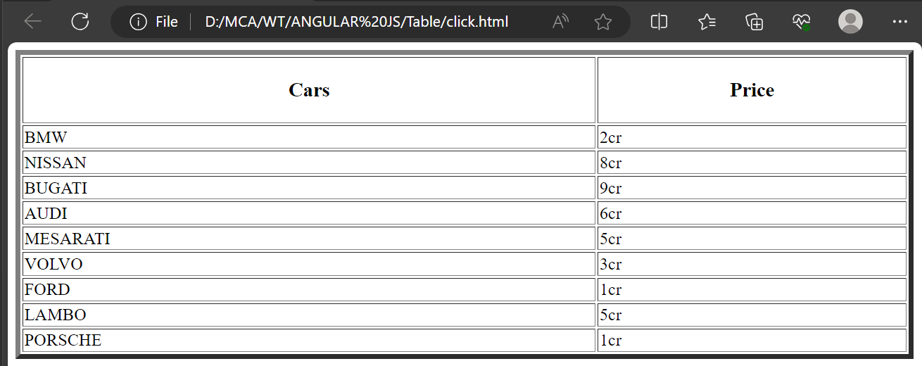

**After Click on Cars (orderBy Cars name)**

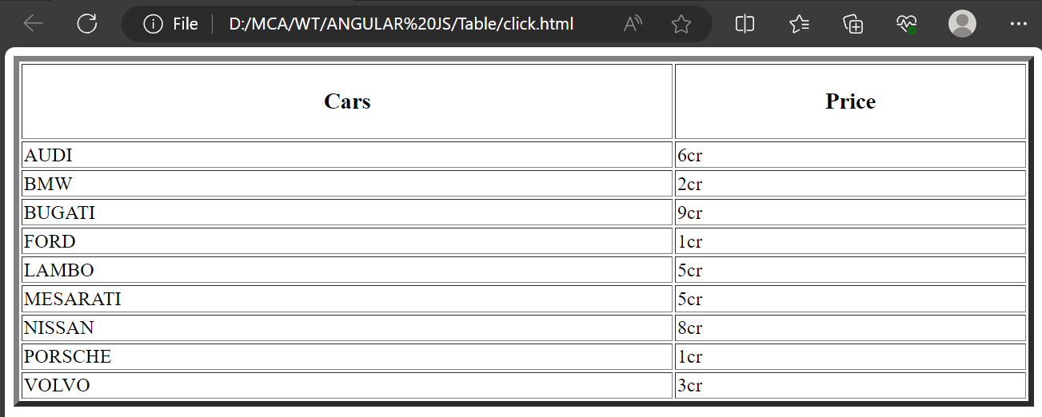

**After Click on Price (orderBy Price)**

